# watsonx Orchestrate Lab 3:

# Connecting an AI Agent to watsonx Orchestrate

Objective

Rule-based solutions and generative AI may not be sufficient to handle complex workflows and processes which have large problem space and multiple steps. However, we can harness the advanced reasoning capabilities and autonomous decision-making of agentic AI to tackle these challenges - watsonx Orchtestrate allows us to employ a network of AI agents, each designed for specific tasks, through agent orchestration to automate complex workflows and processes.

In this lab, you will learn how to connect our agent, deployed on **Code Engine** (similar to lambda in AWS), to watsonx Orchestrate. Any external agents can be integrated with watsonx Orchestrate as long it implements the watsonx Orchestrate external agent [/chat/completions endpoint](https://github.com/watson-developer-cloud/watsonx-orchestrate-developer-toolkit/blob/main/external_agent/spec.yaml) based on the specifications provided. In this use case, we are utilizing [**watsonx.ai’s Agent builder**](https://www.ibm.com/products/watsonx-ai/ai-agent-development)to build and deploy a chat completion service that integrates with IBM watsonx models.

Our custom Python **FastAPI backend** deployed on Code Engine calls the ai_service and ai_service_stream endpoints of the AI service. Refer to the following diagram to understand the flow.

Step 0: Create an AI deployment on IBM watsonx.ai

Due to time constraint, we have created an AI deployment of an agent with access to Google Search and Document Search tools in advance. For more information on implementation, refer to this [documentation](https://github.com/rc-ibm/watsonx-orchestrate-developer-toolkit/tree/main/external_agent/examples/agent_builder#step-0-create-an-ai-deployment-on-ibm-watsonxai).

## Step 1: Create a Code Engine Project

Due to time constraint, we have deployed the backend with the wrapper on code Engine in advance. For more information on implementation, refer to this [documentation](https://github.com/rc-ibm/watsonx-orchestrate-developer-toolkit/tree/main/external_agent/examples/agent_builder#step-1-create-a-code-engine-project).

## Step 2: Register the New Endpoint as an External Agent

1. In IBM watsonx orchestrate Web UI,
   1. Go to “AI agent configuration” from the top left hamburger menu

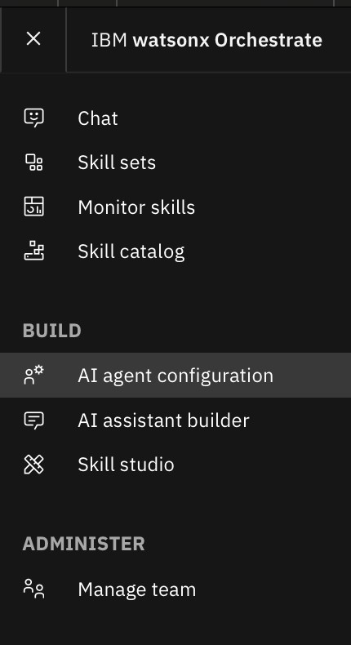

* 1. Select “Agents” from the left-hand navigation
  2. Click the Add agent button on the top right.

1. Enter Details:
   1. Display Name (description of capabilities): [Your Initials] Supplier Research
   2. Description: Does in-depth research on potential suppliers. Finds the best possible supplier based on need. Looks into the suppliers for Xtralife product.
   3. API Key: any string
   4. Service Instance URL: <https://supplier-research.1soswfjkmeox.us-south.codeengine.appdomain.cloud/chat/completions>

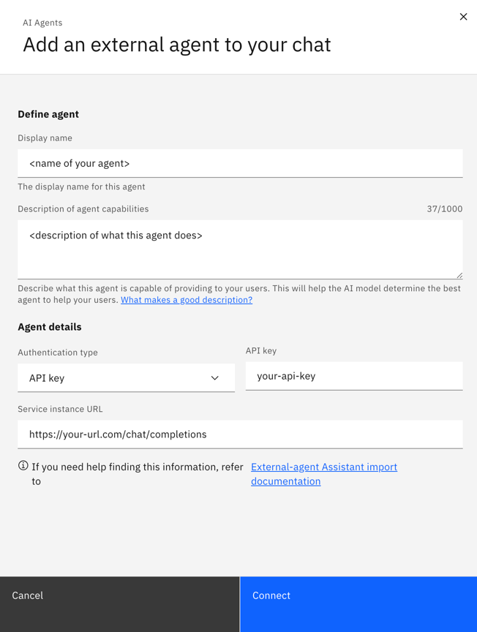

1. CoT rendering (Optional): After you register your agent, you can enable CoT render in AI agent Configuration page. Under Agents tab, click the name of your agent (Supplier Research) and toggle the option “Show thinking in chat”

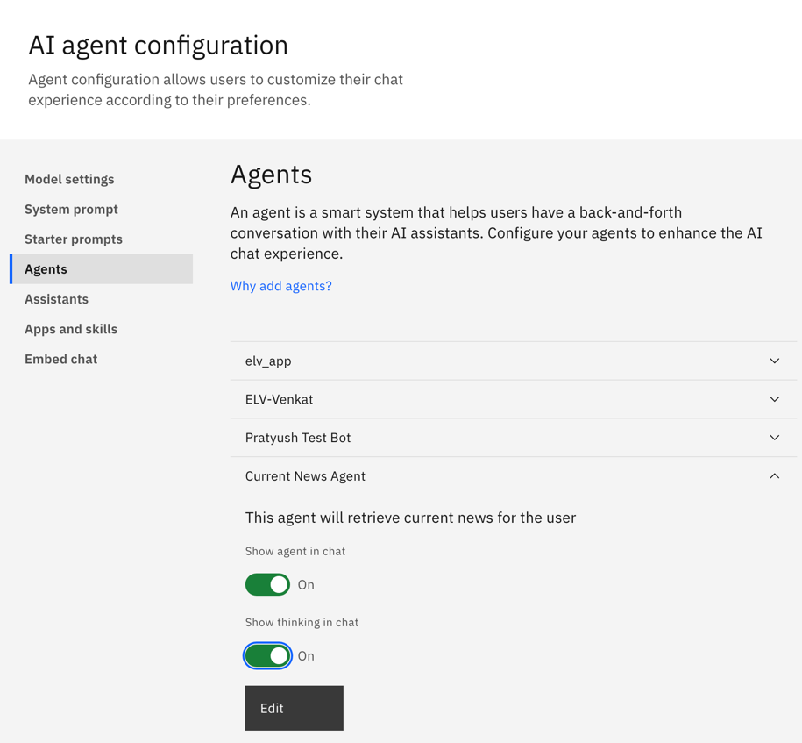

## Step 3: Call the new External Agent from Orchestrate

In IBM watsonx orchestrate Web UI:

1. Select Chat from the left-hand navigation
2. Type a question that should route to the new agent
3. The results from the external agent should be streamed to the IBM watsonx Orchestrate chat window

In the screenshot below, the conversation shows how the agent uses Google search tool to answer a question. Go to “Chat” window from top left hamburger menu and try the following queries:

1. @Supplier Research Which supplier out of Excelentia Supplies and Global Office Supplies is viable to buy product Xtralife from. Give a list of pros and cons of each supplier

1. @Supplier Research Which supplier should i choose? i want an urgent delivery.

## References

* Original Lab with Backend Code: <https://github.com/rc-ibm/watsonx-orchestrate-developer-toolkit/tree/main/external_agent>
* Article on Agents: <https://heidloff.net/article/watsonx-orchestrate-agent-agents/>